End of the Day Prayer
Now the day is over,
We lift our hands and say,
Thank you, Heavenly Father, for today.
We’re sorry for the wrong things,
We’re glad about the right.
Keep us, Heavenly Father,
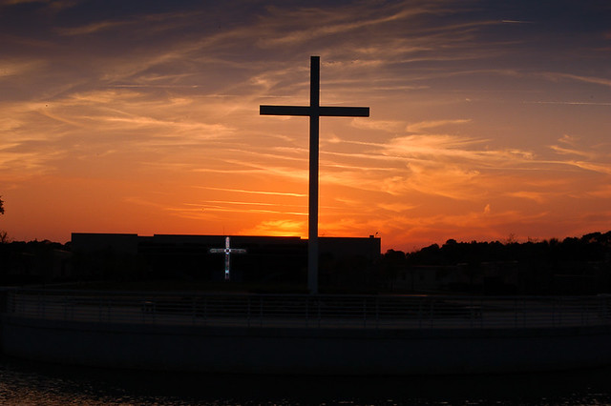
In your love tonight.
Goodnight, God bless
See you in the morning.

