Grace Before Meals

Bless us oh God, as we sit together.
Bless the food we eat today.
Bless the hands that made the food.
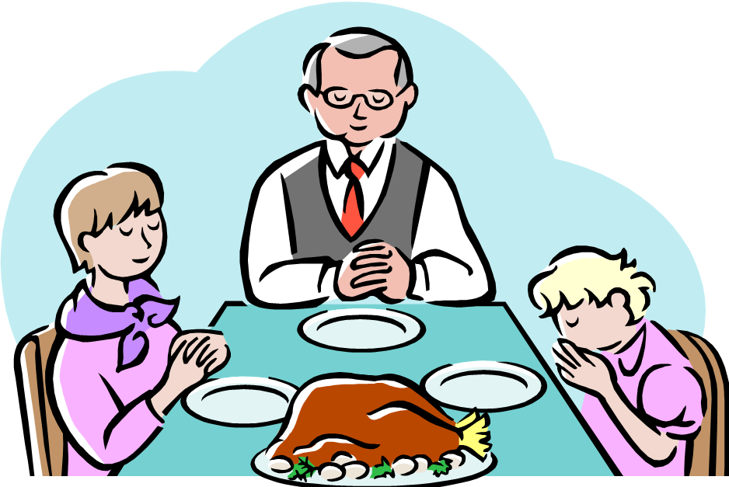
Bless us oh God,
Amen

