Morning Prayer

Oh my God I give to you,
All that I think and say and do.
All my work, and all my play,
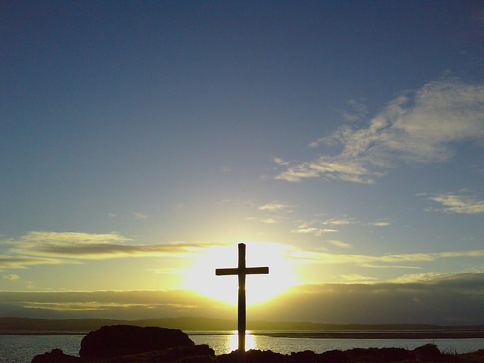
I will give to you today.
Amen

