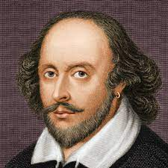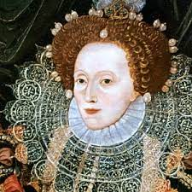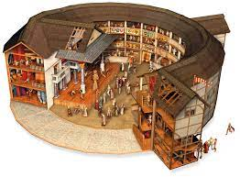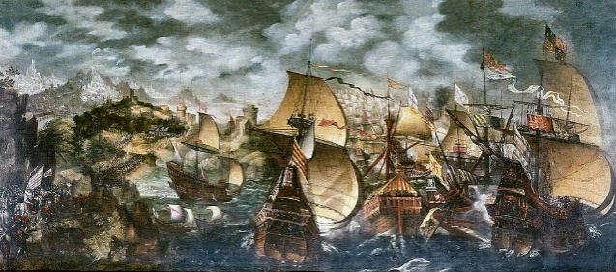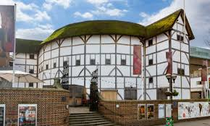

**William Shakespeare**

**and Elizabethan Theatre**

**The Globe Theatre**

Most of Shakespeare’s plays were performed here.

It was constructed in 1599 by the Burbage brothers.

It was octagon shaped, roofless with a stage and 3 galleries surrounding it.

It held about 3000 people

It had to have special permission to have a thatched roof.

**Key Theatre facts**

Women were not allowed to act so men had to play women’s parts

* Richard Burbage was a famous actor who played in may of Shakespeare’s plays and later became part owner of The Globe theatre
* It was very important in the Elizabethan age to give people a break from their ordinary lives.
* Puritans didn’t like the theatre as they thought it was the ‘work of the devil’
* The government used the theatre as propaganda to deliver messages to the public in their plays.
* Nobles liked going as it gave them a chance to dress up and be noticed.
* Queen Elizabeth 1 was a big fan of the theatre.

**Key dates**

1572 – strolling players were banned as it was thought they spread diseases

1576 The first theatre was build (The Theatre)

1595 – Shakespeare’s Richard II and Romeo and Juliet were written.

1599 – The Globe Theatre was opened.

Defeat of the Spanish Armada by Sir Francis Drake– 1588

Establishment of a British Colony in Virginia by Walter Raleigh

Sir Francis Drake circumnavigated the globe

Sir Humphrey Gilbert discovered NewFoundland

**Key Facts about Queen Elizabethan**

Born September 7th 1533

Father was Henry VIII and her mother was Anne Boleyn

Her mother was beheaded when she was 3

She was raised as a protestant

15th January 1559 Elizabeth was crowned Queen following the death of her brother Edward and half-sister Mary

She was a very popular Queen

Her reign was a period of peace and prosperity for England.

Died – March 4th 1603 and buried in Westminster Abbey

**Theatres:**

Many were built during Queen Elizabeth I reign. Usually circular with the only roof being over the actors and the more expensive seats to protect them from the rain. Poorer people could purchase tickets to stand around the stage. A flag was shown above the theatre to show a play was being performed. No scenery was provided.

**Key Knowledge**

1. Shakespeare was believed to be born on April 23rd 1564
2. He was baptised on 26 h April 1564
3. His parents were John and Mary Shakespeare (nee Arden) John came to Stratford from Snitterfield before 1532 as an apprentice glover and leather tanner.
4. Shakespeare had 7 siblings
5. He married his wife Anne Hathaway when he was 18, and she was 26.
6. They had 3 children, Hamnet (boy - died 1596) two daughters Susanna and Judith.
7. He is the world’s most famous playwright.
8. He wrote over 30 plays and a variety of sonnets (love poems)
9. Shakespeare died in