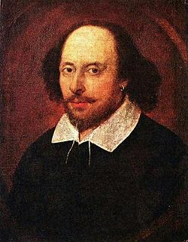

Dear Parents,

We are looking forward to a very busy final term at St Winefride’s for Year 6. We have SATS, our trips to Young Voices and London, our Year 6 production, Leavers Mass, and many more exciting activities planned.

This term our topic is ‘Shakespeare and Elizabethan Theatre and will link to our production.

The children have been working hard towards their SATS, and we are ready for next week. We will need to keep working hard at writing after SATS as the assessment for that does not happen until June. During SATs week, we would encourage the children to go to bed in good time so that they are ready for each day. We will be providing breakfast for Year 6 from Monday to Thursday during SATs week, a further letter about that has been sent already.

During this term, the children will have transition days to their high schools, you should have had information about this but if not please contact the high schools directly.

It would really help if you could ensure that your child has their PE kit in school each day as we try and make the most of the (hopefully) better weather once SATs are over to do a bit more PE. If your child does not have PE kit or appropriate footwear, they will not be able to participate. Please could you also ensure that your child has some form of raincoat with them daily.

If you have any concerns or queries, please do not hesitate to make an appointment to see us or have a telephone conversation with one of us after school.

Best wishes

Mrs Broadley and Mrs Boyd

