**Science**

I can identify and name a variety of common wild and garden plants, including deciduous and evergreen trees.

I can identify and describe the basic structure of a variety of common flowering plants, including trees.

I can observe changes across the four seasons.

I can describe weather associated with the seasons and how day length varies.

I can use practical scientific methods, processes and skills.

**Year One - Pentecost One**

**RE**

I can recognise what a holy day is and the story of the coming of the Holy Spirit at Pentecost.

I can recognise many ways in which the Holy Spirit helps and guides us.

I can recognise many parts of the Last Supper story.

I can recognise many religious signs, symbols and words linked to Communion at Mass.

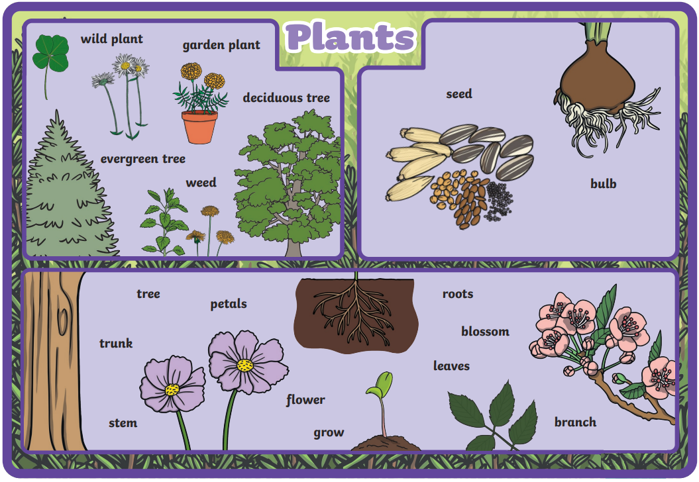

**PHSE**

I can be responsible.

I can identify how I can contribute to the life of the classroom and school.

I can construct and explore the importance of rules.

I can recognise what is fair/unfair, right/wrong, kind/unkind.

**Art, Design and Technology**

I can use the basic principles of a healthy and varied diet to prepare dishes.

I can use a range of materials creatively to design and make products.

**ICT**

I can use computer programming.

**Maths**

I can solve one step problems involving multiplication and division.

I can recognise, find and name a half and a quarter f an object, shape or quantity.

I can describe position, direction ad movement.

**English**

I can make predictions.

I can write instructions.

I can write a poem.

I can sequence sentences.

I can re-read what I have written to check it makes sense.

I can use the suffix -ing and -er.

I can use imperative verbs.