Year 3 Autumn Term
Newsletter

Dear Parents

Welcome to Year 3. Children in Year 3 are taught by myself, Mr Smith and will also be assisted during Advent and Pentecost term by Miss Kendrick.
This is another important year for the Year 3 children as they make the step up into KS2.

Please find below some information about Year 3 and some things we will be doing during the Autumn Term.
Reading
Children will read daily in their English lessons. In addition to this, they will read in group sessions, and
on a one-to-one basis as necessary. Reading at home as often as possible will also continue to benefit
them particularly as the texts become more challenging in year 3.

Maths
Alongside this letter, you will have received a copy of the ‘Must Do’s’ for Maths, which details what is expected of children by the end of Year 3. It would help your child if you could work on these with them at home throughout the year, particularly the objectives relating to times tables.

Autumn Term Curriculum
Our topics for the Autumn Term is the Stone Age and the Neolithic periods followed by Volcanoes. We will be learning about how people lived during the Stone Age through our History work, and will be investigating rocks, light and dark in science.

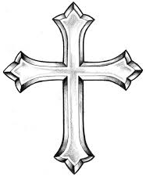
R.E. Curriculum
The three topics for the Autumn Term that we will be covering are Homes, Special places and Visitors. Each topic has a ‘big question’. It would be useful if you could discuss these questions with your child at home. These are as follows:
What makes a house a home?
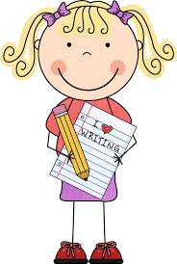
What makes a place special?
Are visitors always welcome?

Homework
It is important for you to support your child with their homework and reading, but also
encouraging them to do as much as possible by themselves – for example asking the
children to read the questions themselves rather than reading the questions to them.
Homework will be set on class dojo and will consist of weekly spellings (which will be tested in class on Friday) as well as another piece which will be either related to something that we are learning about in class or a page from the grammar books which will be going home this week. We will also continue to be using Bug Club and Times Tables Rockstars, the log ins for which will be stuck into the children’s organisers in due course.

P.E.
P.E. will be on Tuesday mornings. We ask that on this day children have their PE kits in school ready to get changed into.
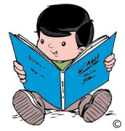
Reading books– it is important that children read daily and should change their reading books at least once
each week. To develop their independence with making choices about what they like to read, children are
able to change their own reading books. This can be done during the school day, so please remind your child on the way into school if they need a new reading book.
Reading organisers must be brought into class every day, even if your child hasn’t read, as these are monitored daily.
We have a number of reading schemes in school, which are organised into Book Band colours. This may mean that your child has books with different stage numbers, but they will be at the same Book Band level.

School Uniform
Please ensure children wear correct school uniform and that all of their uniform is named.

I hope this newsletter has given you a useful insight into some of the activities that will be taking place this term however if you have any questions regarding your child’s learning or have any other queries or concerns during the year, please do not hesitate to speak to myself after school, or by prior appointment via the office.

Mr Smith

