
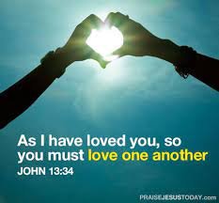
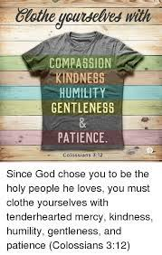
Rules
Year 2 Topic 8
OUR BIG QUESTION
Are rules important?
WHAT I COULD DO AT HOME
Think about how rules can help at home.
Jesus’ special rule for us is, ‘Love one another as I have loved you.’ Think about how you can follow this rule.
Find out something about the Sacrament of Reconciliation
SCRIPTURE

Colossians 3: 10-17 Matthew 3: 13-17 John 13: 34-35
God’s rules for his people The disciples ask about Love one another
forgiveness

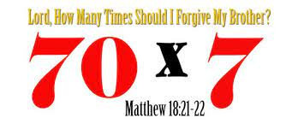

KEY VOCABULARY

rules
care
safe
sorry
forgive
right
wrong
make up
choices
sin
consequences
examination of conscience
Sacrament of Reconciliation
SACRAMENT OF RECONCILIATION

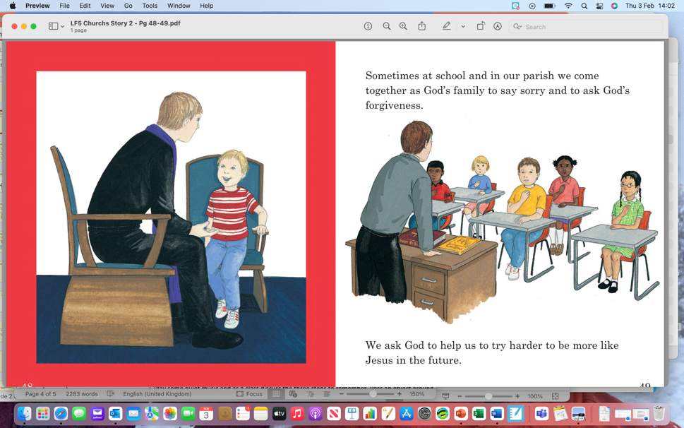

KEY KNOWLEDGE

I can talk about the importance of keeping rules.
I know how rules are necessary in my life.
I can talk about how it is hard to say sorry, how it is sometimes hard to forgive others and the good feeling it is when people make up.
I can describe some aspects of the Sacrament of Reconciliation.
I can describe how Christians try to practise Jesus’ commandment of love, peace and reconciliation.

