

Building Bridges
Year 4 Topic 4
SCRIPTURE

Luke 15: 3-7 Mark 12: 30-31 Matthew 5: 23-24 Colossians 3: 12-15
The Lost Sheep Love the Lord with all your heart Gifts for God God’s Chosen Ones
Building Bridges
Networks of friendships and relationships enable human beings to live together.
If human beings are to live together in relationships, there is always need for reconciliation.
KEY KNOWLEDGE

I understand the importance of conscience in making choices.
I know the meaning of the word reconciliation.
I know why it’s important to build bridges of friendship.
I know when I must say sorry.
I know what it means to be a friend of God.
I know where I can go to make a confession and what this means in the eyes of God.
I know the importance of admitting wrong and being reconciled with God and one another.
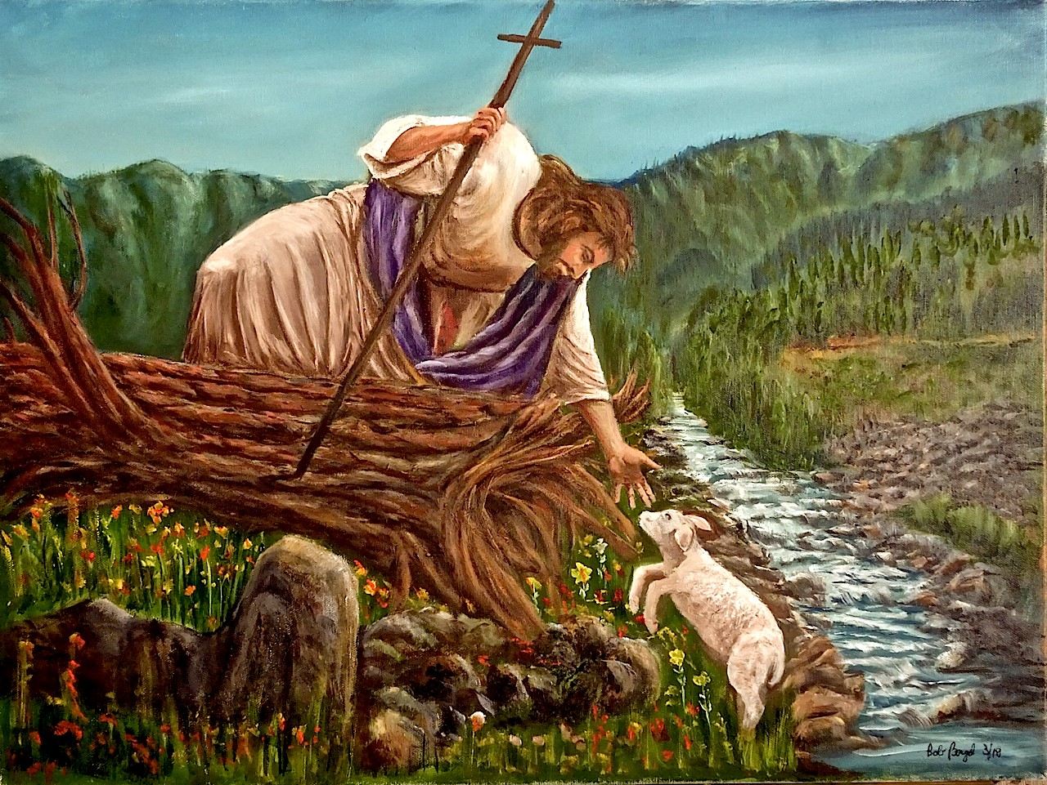



OUR BIG QUESTION
Why are bridge builders important?

REFLECTION
I have chosen the way of faithfulness;
I set your ordinances before me.
I cling to your decrees,
O Lord; let me not be put to shame.
I run the way of your commandments,
for you enlarge my understanding.
Teach me, O Lord, the way of your statutes,
and I will observe it to the end.
Give me understanding that I may keep your law
and observe it with my whole heart. Amen.
(Psalm 119: 30-34)

KEY VOCABULARY
bridges, friendship, Sacrament of Reconciliation, Examination of Conscience, sin, penance, confession

