
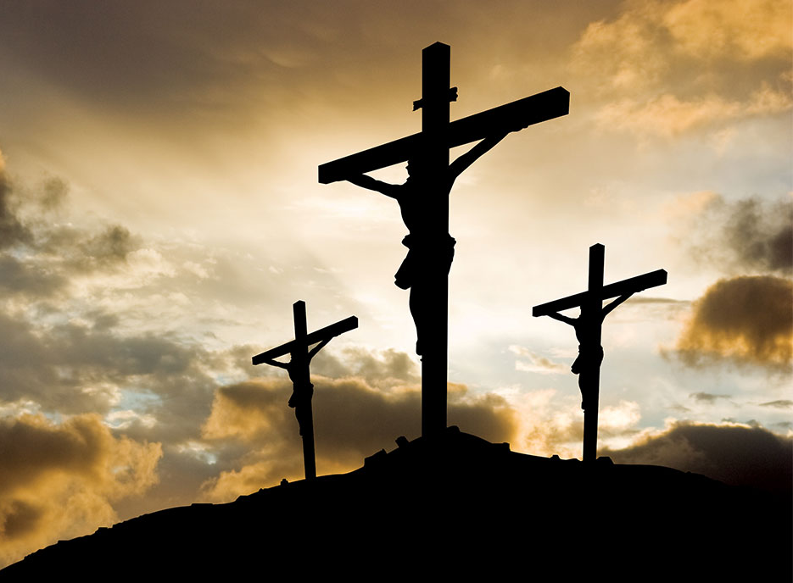
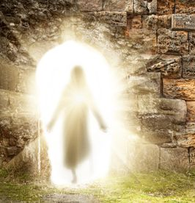
Self-Discipline
Year 4 Topic 6
SCRIPTURE

Matthew 6: 2-4 Luke 6: 27-28, 32-36 John 13: 4-9, 12-15 Mark 15: 23-41 Mark 16: 2-8
About Giving Love the Lord with all your heart Jesus washes the disciples’ feet The Crucifixion The Resurrection
Self-Discipline
Lent is part of the Liturgical Year when people unite themselves with Christ in order to grow in self-discipline through the practices of prayer, fasting and almsgiving. We celebrate growth of new life in Christ, in preparation for the feast of Easter.

KEY KNOWLEDGE

I understand the importance of showing self-discipline in the choices I make.
I understand that Lent is a time for self-discipline and fasting.
I know the events of Holy Week, including Maundy Thursday, Good Friday and Easter Sunday.
I know that the Resurrection symbolises new life.
I know that we help others who are less fortunate than us during the Lenten period.


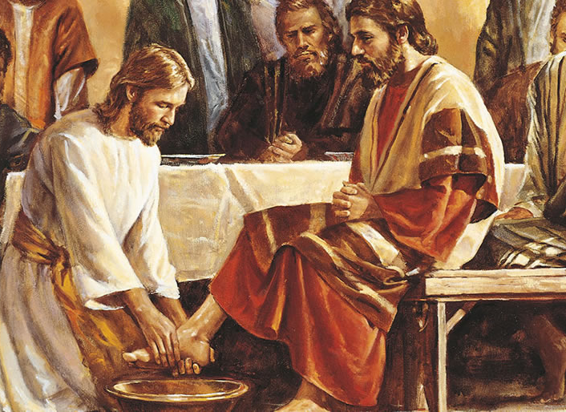

OUR BIG QUESTION
Is self-discipline important in life?

REFLECTION
Lord, when I am hungry, give me someone to feed; when I am thirsty give water for their thirst.
When a burden weighs upon me lay upon my shoulders the burden of my fellows.
Lord, when I stand greatly in need of tenderness, give me someone who yearns for love. May your will be my bread; your grace my strength; your love my resting place.

KEY VOCABULARY
Self-discipline, Lent, resolution, effort, potential, penance, contrition, Easter, Resurrection, fasting, alms giving

