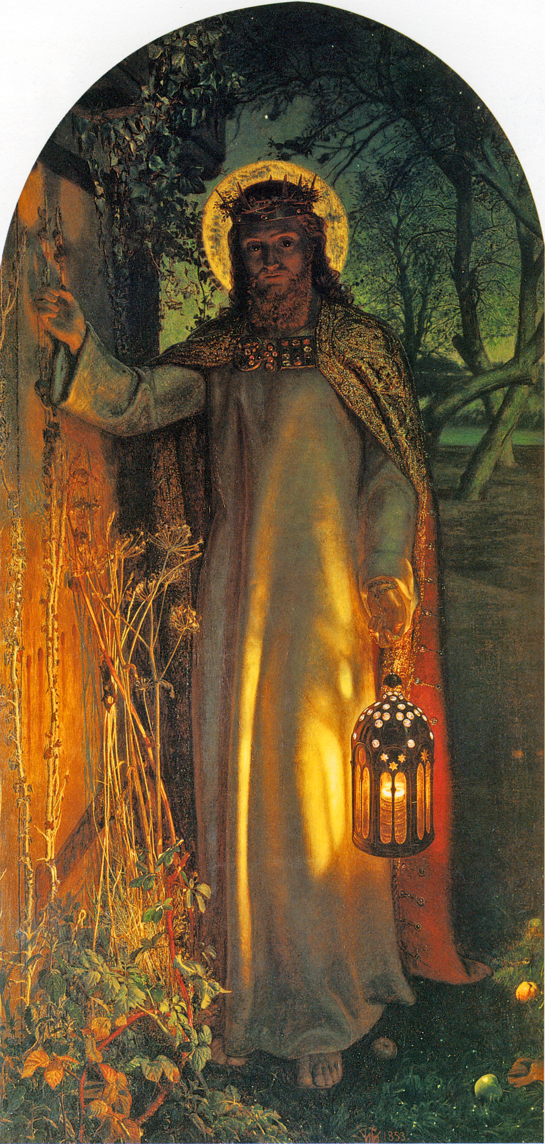

HOPE
Year 5 Topic 3
OUR BIG QUESTION
What does it mean to live in hope?
KEY VOCABULARY
waiting hopeful
promised one
Messiah prophet
REFLECTION
Today a saviour is born!
In the stillness of the night God enters human history
through the birth of his own Son.
He is our peace and hope.
In him we praise God for his goodness to s in giving us so great a gift.
Amen
KEY KNOWLEDGE
I know that Advent is a time to remember God’s promise to send a Messiah. It is about waiting in joyful hope for the coming of Jesus at Christmas as the people of God were waiting for the Messiah.
I know what the prophets Isaiah and Jeremiah said about the coming of the Messiah.
I know that Isaiah describes the one who was waited for, as being like a light in the darkness.
I know the story of the birth of Jesus.
I know that Christians believe that Christ will come again in glory.
ADVENT
Advent is the church’s season of waiting in joyful hope for the coming of Jesus, the promised one, at Christmas and at the end of time.
SCRIPTURE
Psalm 27: 13-14
1 Samuel 16: 4-13
Isaiah 9: 2-3, 6-7
Isaiah 25: 8-9
Isaiah 40: 9-11
Jeremiah 33: 14-16
John 1: 5
Matthew 1: 1-17
Matthew 1: 18-25
Mark13: 33
Luke 1: 38-57
James 5: 7-8

The Light of the World
by William Holman Hunt

