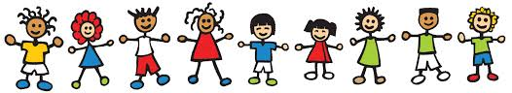
Year 2
Lent Term
Newsletter

Dear Parents

A warm welcome back and I hope you had an enjoyable Christmas and New Year.
This term we have trainee teacher, Mr Eling, working with us.
Please find below some information about Year 2 and some things we will be doing during the Lent Term.
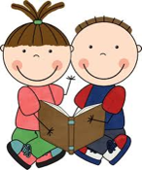
Reading at school - Children will read daily in their English lessons. In addition to this, they will read in
group sessions, and on a one-to-one basis as necessary.

P.E.
P.E. will be on Tuesday afternoons, so please ensure your child has their P.E. kit in school on this day. The P.E. kit uniform is listed in your child’s organiser. Please ensure all P.E. kit is named.

Spring Term Curriculum
Our topics for the first half term are: Materials (Science) during which we will be learning
about everyday materials and their uses; and Victorians (History) where we will be learning
about life in the Victorian times and comparing it with life today.
During the second half of the Spring term our topic will be London (Geography), where we will be
learning about the UK focusing on London transport and famous buildings.

R.E. Curriculum - There are three topics for the Spring Term. Each topic has a ‘big question’.
It would be useful if you could discuss these questions with your child at home.

Books
In this topic the children will explore books used at home and at school. We will learn about the
books used in Church on Sunday and some of the responses we make during the service.
Big Question: Why do we need books?

Rules
Children will learn about rules we have at school, at home and at other times and why these are necessary. We will learn about Jesus’ teaching about rules and explore the ideas of saying sorry and forgiveness.
Big Question: Do we need rules?

Opportunities
In this topic we will look at how each day offers opportunities for good. We will learn about Lent as a time to turn towards what is good, in preparation for Easter.
Big Question: How does each day offer opportunities for good?

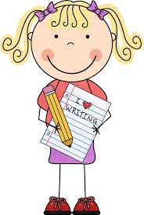
Homework
It is important for you to support your child with their homework and reading, but also
encouraging them to do as much as possible by themselves – for example asking the
children to read the questions themselves rather than reading the questions to them.
Homework will mostly be communicated via Class Dojo. Please ensure that you have signed up
to your child’s Class Dojo.

Spellings
Spellings will be given weekly and tests will be on Fridays. Please support your child with learning their spellings.

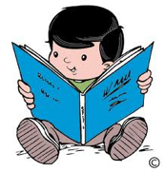
Reading at home – it is important that children read daily at home for 10-15 minutes. Children will be given one scheme book each week chosen by their class teacher. In addition to this, children will be choosing some books from the KS1 library to bring home each week. These books are for you to share together and can be read either by your child or to your child. This is to support with children’s reading enjoyment and to support with building vocabulary. Books will be changed on your child’s book changing day which is recorded in their reading organisers.
Reading organisers must be brought into class every day, even if your child hasn’t read, as these are monitored daily.

School Uniform
Please ensure children wear correct school uniform and that all of their uniform is named.

Water Bottles
Children can have water bottles in class. Bottles must only contain water, not juice.

I hope this newsletter has given you a useful insight into some of the activities that will be taking place this term. If you have any questions regarding your child’s learning or have any other queries or concerns during the term, please do not hesitate to speak to myself after school, or by prior appointment via the office. Non-urgent messages can be sent via Class Dojo (please remember that this may not be checked every day). Any urgent messages in the morning can be communicated via the school office.

Mrs Monk

