God's Story 2 - Pg 81.tifGod's Story 2 - Pg 89.tif/////

**SCRIPTURE**

**Luke 24: 1-9 John 13 Luke 24: 48-52 Acts 2: 1-4 Thessalonians 4: 13-14 Romans 8: 22-28**

**The Resurrection The Promise of the Holy Spirit The Ascension Pentecost Day Passing on the Good News Spread the word**

Spread the Word

Year 2 Topic 7

**OUR BIG QUESTION**

Why should we spread Good News?

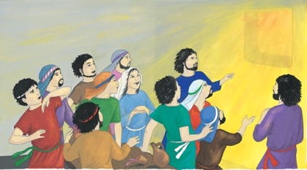/

**ASCENSION**

**KEY VOCABULARY**

* message
* risen
* Resurrection
* Holy Spirit
* Ascension
* witnesses
* blessing
* Pentecost
* promise
* Good News

**WHAT I COULD DO AT HOME**

* Think about the importance of messages in my daily life and the responsibility of passing on messages.
* Talk together about how the Holy Spirit helps Christians.
* If you have a Bible at home, read the stories from the Scripture section, or you can watch Pentecost Day using this link:

<http://www.viewpure.com/OMQKy1Mx49M?start=0&end=0>

**KEY KNOWLEDGE**

* I know on Easter Sunday we remember that Jesus rose from the dead.
* I know Jesus’ promise of the Holy Spirit.
* I know on the Feast of Ascension, the Church celebrates Jesus’ return to his Father in Heaven.
* I know what happened on the first Pentecost Day to the disciples in the upper room.
* I know Jesus has promised new life.
* I know ways of spreading the Good News about Jesus.