/////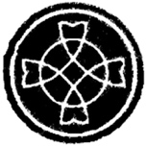

**KEY KNOWLEDGE**

* Talk about your own experience and feelings about signs which help you in daily life and the symbols which are important to you.
* Say what you wonder about the meaning and importance of some symbols in your life.
* Recognise the signs and symbols used in baptism.
* Use some religious words and phrases used in the Sacrament of Baptism.
* Recognise that Christians act in a particular ways because they are members of the Church family.
* Describe some actions and symbols used in baptism.
* Describe some ways in which Christians live as followers of the Light of Christ.

**KEY VOCABULARY**

* garment
* Easter candle
* font
* oil of Chrism
* Good News
* sign
* symbol

Signs and Symbols

Year 2 Topic 9

**OUR BIG QUESTION**

Are signs and symbols important?

/

**SCRIPTURE**

**Jesus is Baptised**

**Matthew 3: 13-17**

**WHAT I COULD DO AT HOME**

* Talk about the meaning and importance of some symbols in my life.
* Talk about the power of the symbols used in Baptism.
* Find out if I have been baptised and look at the symbols from my baptism.
* If you have a Bible at home, read the story of Jesus’ Baptism, or you can watch it using this link:

<http://www.viewpure.com/_VMNO2MAmwA?start=0&end=0>

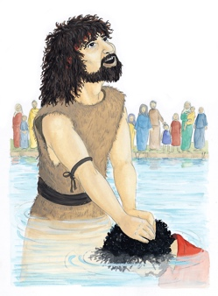

**Some symbols of Baptism**

**Easter candle font and oil white garment the sign of the cross water**

